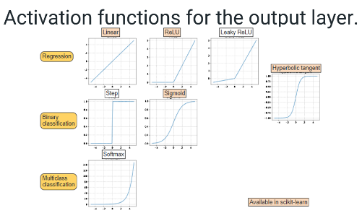NN: mimic the brain to do computation

**Feed-forward network**: Directed acyclic graph. No internal state. Simply computes outputs from inputs

**Gradient descent** is an optimization algorithm that adjusts weights based on the loss function's derivative.



Where η is *step size*,

how far to step relative to the gradient

* Large learning rates update weights quickly but may fail to converge to the loss function's minimum.
* Small learning rates take more iterations to train but are more likely to converge.
* Setting v= 0.0001 results in a smooth loss curve on the training set. v= 0.0001 is the optimal learning rate, since the loss function has the lowest value.
* Increasing the learning rate gives a loss curve that converges faster. But, the minimum loss using v = 0.001 is higher than the loss from the optimal learning rate.
* When the learning rate is too high, the loss function converges, but at a relatively high loss.

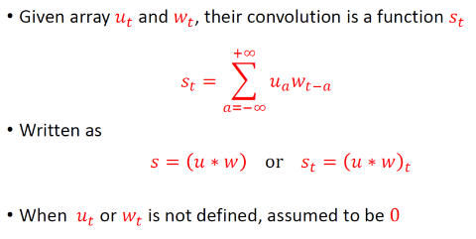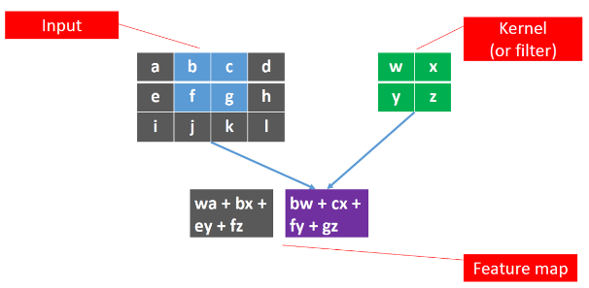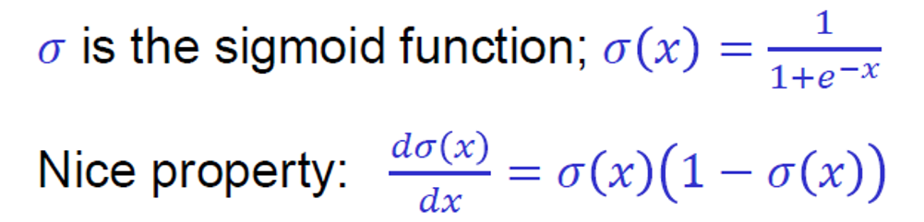

Make weak model more powerful: boosting!

Make strong model less likely to overfit: regularization

Convolutional neural networks

**Convolutional Layer**:

Input: an image  
Processing: convolution with multiple filters  
Output: an image, # channels = # filters

Output still weighted sum of input (w/ activation)

**Pooling Layer**:

Input: an image  
Processing: pool pixel values over region  
Output: an image, shrunk by a factor of the stride

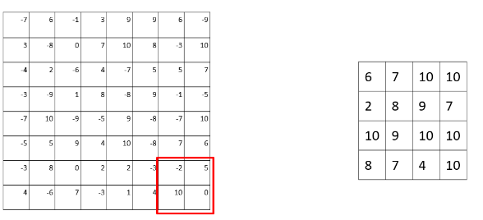Hyperparameters:  
 What kind of pooling? Average, mean, max, min  
 How big of stride? Controls downsampling  
 How big of region? Usually not much bigger than stride

Most common: 2x2 or 3x3 maxpooling, stride of 2

**Residual connections**:

Normally, output of two layers is: f(w*f(vx))  
Residual connections: f(w*f(vx) + x)

Learning how to modify x, add some transformed amount  
Gives delta another path, less vanishing gradient

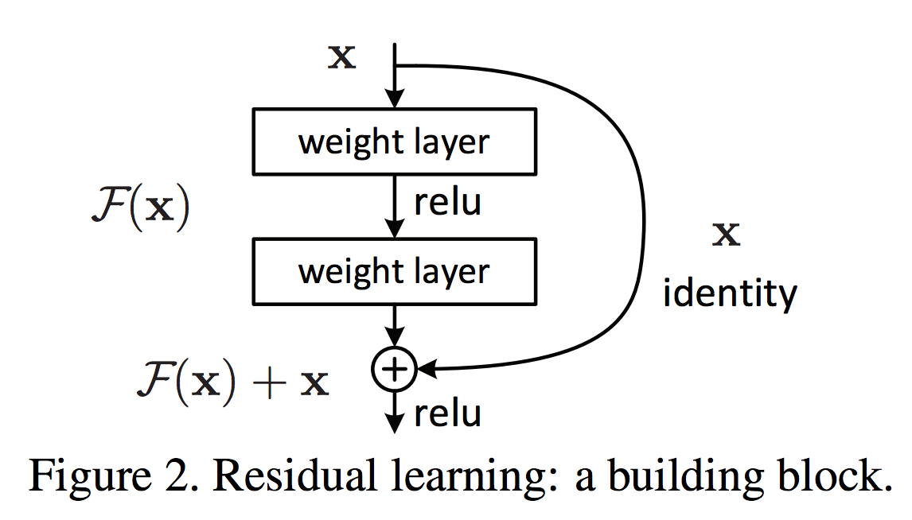

**Recurrent Neural Network (RNN):** the output from the previous step is fed as input to the current step

**Autoencoders**: are a class of neural networks that learn efficient codings or labelings for unsupervised learning tasks. Autoencoders consist of two functions: Encoding functions transform the input data into a new latent space, which is typically smaller than the original inputs.| Decoding functions re-create the input data from the transformed latent space.

**Transfomers** are deep learning models that use attention mechanisms to amplify or diminish the importance of specific words in a sequence

1. Transformers contain two blocks: an encoder block and a decoder block. The encoder block passes the inputs into an attention mechanism.
2. The attention mechanism assigns weights to each element in the input. Ex: "I" is assigned weight 0.3, "like" is assigned weight 0.1, etc.
3. The attention vectors pass into a multilayer perceptron.
4. In the decoder block, shifted outputs pass into a separate attention mechanism. Ex: "I like the color" translates to "Ich mag die Farbe" in German. The last word, "blue", is not included.
5. The inputs pass from the multilayer perceptron into a new attention mechanism along with the output's attention.
6. The combined attention passes into a final multilayer perceptron that produces the output.

**Graph Neural Network**

Intuition: Network neighborhood defines a computation graph



Neighborhood Aggregation : Variants

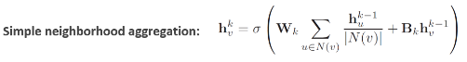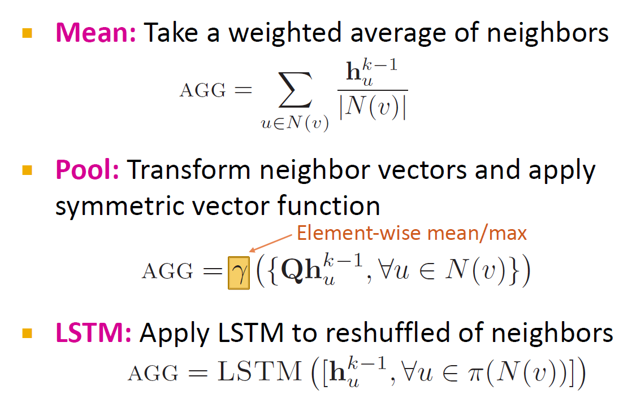

**GAT**: Graph Attention Network

**Clustering**



**K-Means Clustering**

Pick K random points as cluster centers (means)

Shown here for K=2

Iterative Step 1

Assign data points to closest cluster center

Iterative Step 2

Change the cluster center to the average of the assigned points

Repeat until convergence

**Strengths**:

K-means is the most popular clustering algorithm

Simple: easy to understand and to implement

–Efficient: Time complexity: O(tkn),

where n is the number of data points,

k is the number of clusters, and

t is the number of iterations.

Since both k and t are small. k-means is considered a linear algorithm.  
**Weakness**:

Applicable only when “mean” is defined? What about categorical data?

Need to specify the number of clusters, 𝑘𝑘, in advance

The algorithm is sensitive to outliers Unable to handle noisy data and outliers

Not suitable to discover clusters with non-convex shapes

Too Sensitive to Initialization

Bad initialization leads to poor results.

**K-means++**

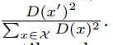Place the initial centroids far away from one another:

Initialize an empty set M (for storing selected centroids);

1. Randomly select the first centroid from the input sample and assign it to M

2. For each xi that is not in M, find the distance D(xi) to the closest centroid in M

3. Choose one new data point at random as a new centroid using probability distribution ~

4. Repeat (2) and (3) until K centroids have been chosen

Then do “classic” k-means

**Hierarchical Clustering:** Start with single-item clusters, then build successively bigger and bigger clusters: **agglomerative**: In each iteration, we find the closest clusters and merge them| Or: start with one cluster, break into the most logical sub-clusters, repeat: **divisive**: : In each iteration, we find the two most distant sub-clusters and split there

**Distance Between Clusters**

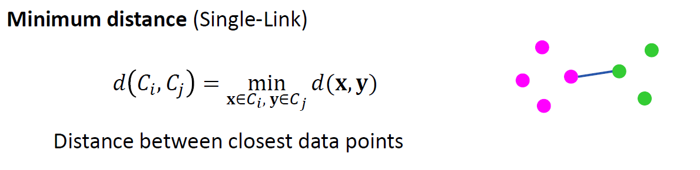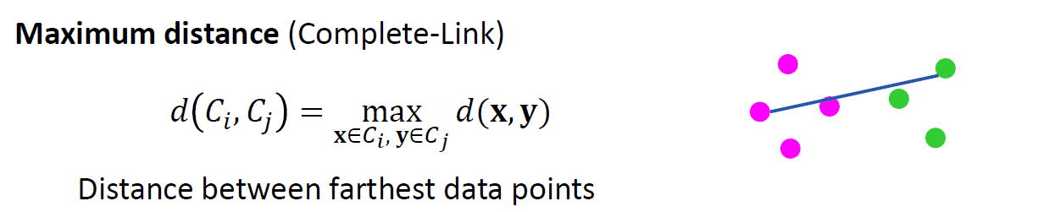

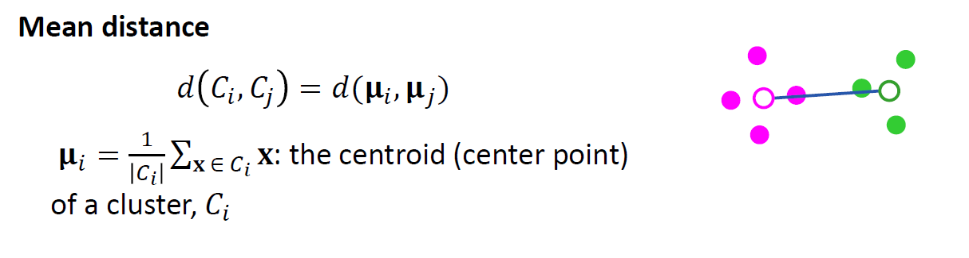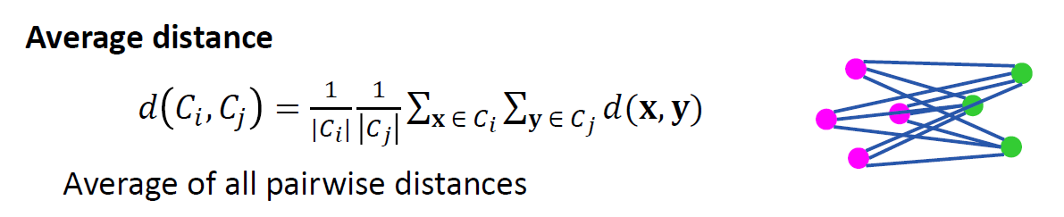the most widely used measure Robust against noise

**Network Density:** the portion of the potential connections in a network that are actual connections

Proximity: many, short, or heavy paths

1. a. (15) You own a movie theater and. You start with the following dataset with data about 6 people with different age groups, income levels, and whether or not they frequently go to movie theaters. In particular, you are going to build a decision tree to predict whether or not someone is a frequent movie-goer. Based on the principle of information gain, decide which attribute is to be used for the first split? After first split, what we do we need to do to get complete tree?

IG(Y |X) = H(Y ) − H(Y |X)

𝐻 ( 𝑆) ≡ −𝑝⊕ log2 𝑝⊕ − 𝑝⊖ log2 𝑝⊖

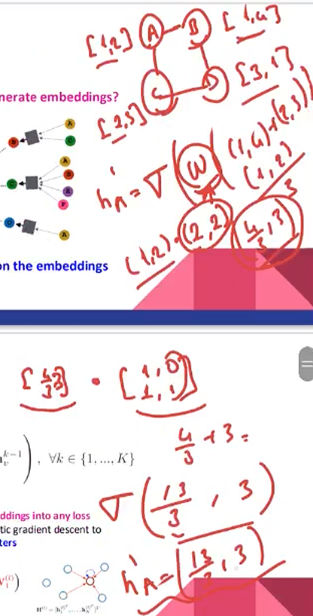

c.For Adaboost ensemble model, we will use decision trees as our weak learners, which classify a point as {1, −1} based on a sequence of threshold splits on its features (here x, y).

i. Assume that our weak learners are decision trees of depth 1 (i.e. decision stumps), which minimize the training error. Using the dataset below, draw the decision boundary learned by h1.

ii. Using your answer in (i) circle the point(s) with the highest weights on the second iteration, and draw the

decision boundary learned by h2. Explain your answer ( on the given figure and named h2)



2. (25) Bayesian Network

a. (5) Write the joint probity of P(A, B, C, D, E) according to the Bayesian network given in figure.



b. (10) Give the formula that calculates P(C=True| B=True, D=True,) according to given Bayesian Network. Show your steps and open it till you cannot where you need to plug probabilities



c. (10) Prove or disprove whether the following independence properties hold on the given Bayesian Network. X ⊥ Y | Z if P(X, Y | Z) = P(X | Z) * P(Y | Z)

1. (B⊥D) T

2. (B⊥D|E) F

3. (C⊥D|A) T

4. (C⊥D) F

3. a) (10) For given dataset, we need to classify whether the car is stolen, given the features of the car. The features are assumed to be Independent.

For a car with yellow color and SUV type, find the label using naive bayes on the given dataset.

Show your steps

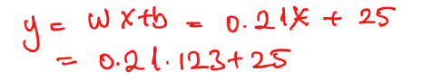

4. a) Ecologists have long known that there is a relationship between the amount of precipitation a location receives and the number of trees that grow in the area. Suppose that the yearly rainfall (x) and the amount of the ground covered by trees (y).

Use linear regression model with w=0.21 and b=25 to predict tree grow given rainfall Calculate the predicted amount of tree cover for an area that receives 123 mm of rainfall per year.

b) (7)Write the equation for logistic regression. What is the difference from Linear Regression? Which loss function can we use for Logistic regression model?



5. a. What is the difference between supervised and unsupervised learning?



b. (6) What are overfitting and underfitting problems of Machine learning? Shortly



c. (5) How can we choose k for Nearest Neighbor? Explain small and large k conditions



d. (4) How to avoid overfitting for Decision Tree?



e. (4) How to solve multi class problem with a linear function like SVM?



f. (4) What is the difference between linear regression and SVM?

